Procedures for Use of the Emergency Trading Floor of China Financial Futures Exchange
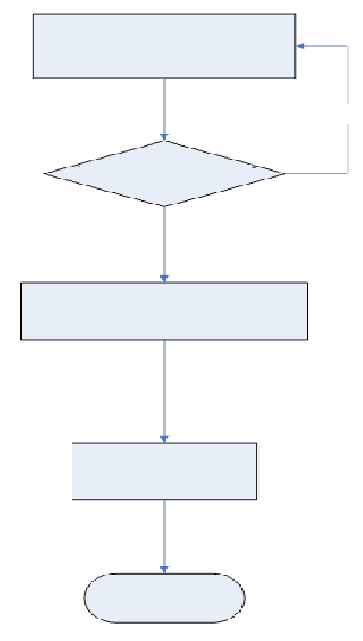
The Exchange accepts and reviews the application of the member

The member’s emergency trading personnel enters the emergency trading floor after the verification of its ID card and other certificates
rs enter the Emergency Trading Floor upon verification of their ID cards and other certificates

Carry out emergency trading

Leave the emergency trading floor

The application is not approved

A member submits an application form for use of the emergency trading floor
Notes:
- After using the emergency trading floor, a member is required to submit additional written materials for its current failure.
- Under emergency circumstances, the member may fax the application form for use of the emergency trading floor to the Exchange’s Trading Department on 021-50160397 and subsequently submit an original copy of the application form.

